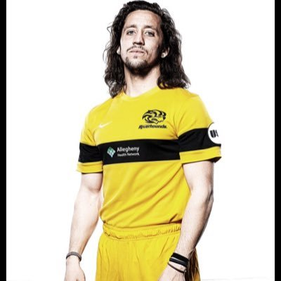
Nick Kolarac Pro Soccer CV
Winger, Def/Att Mid 5’9” 160 lbs/ 175cm, 72kg / Age: 24
Signed pro contract Pittsburgh Riverhounds 2 years (USL) 15’-16’
Signed contract with Philadelphia Fury (ASL) 14’
National PDL Champion with Michigan Bucks 14’
Saint Francis University (PA) Division 1 NCAA
Michigan Bucks PDL 14’/IMG ACADEMY PDL 13’
MLS Combine Alternate 14’/USL Combine Attendee 14’
Trials: Colorado Rapids, Real Salt Lake both (MLS) contract offered by Tindastoll FC in Icelandic Premier League

Pittsburgh Riverhounds (USL) Dec14’-Oct16’- Two years with the Riverhounds appeared in 12 matches for the hounds with 2 starts. Played in matches as right back, holding mid, and winger.

Philadelphia Fury (ASL) Aug-Nov 14 ‘– Started all 10 games for the Fury playing winger, attacking midfield, and forward. 4 goals and 5 assists in 10 games was 2nd on team in goals, 1st in team on assists.

CAREER STATS at Saint Francis University
Season | GP | G | A | Pts. | GW | SH
2010 | 16 | 1 | 4 | 4 | 0 | 15
2011 | 18 | 2 | 3 | 7 | 1 | 29
2012 | 20 | 5 | 3 | 13 | 3 | 64
2013 | 19 | 12 | 4 | 26 | 3 | 76
TOTAL | 73 | 20 | 14 | 54 | 7 | 186
Michigan Bucks (USL) May-Aug 14’ – National PDL Champion started 17 of 18 games played winger, defensive and attacking midfield had 1 goal and 5 assists. Helped the Bucks have the least goals scored against in PDL with 9 and the most goals scored with 53.

Saint Francis University 10’-14’ – 3 time all NEC conference award winner, 2 time All North Atlantic Region winner, led team in points junior and senior season. Top 10 in the nation in goals and points in 2013. 2 time captain and 4 year starter.

IMG Academy PDL (2013) – Played Central Midfield, Winger for IMG PDL team started 10 out of 14 games had 3 assist and 22 shots.
Youth – Region 1 ODP team traveled to Italy. Led the nation in assists for high school players my senior year with 36 in one season. Century United Club 7 year’s state cup champs twice, multiple tournament winners. MVP of high school 3 years in a row, MVP of Century United 2 years in a row. Ranked as 4th recruit to come out of Pennsylvania for TopDrawerSoccer.
Agent- Pete Smith. Email: PeterJSmith3rd@gmail.com Phone: 202-423-8860
References
Michael Casper Notre Dame Assistant Coach
Cell - 814-330-8737
Mark Steffens Pittsburgh Riverhounds/Charlotte Eagles Coach
Cell – 704-737-9227
Dave Grey Century United Coach/Duquesne Soccer Coach
Cell - 412-719-5542
Gary Parsons Michigan Bucks General Manager
Cell - 248-563-6691
Email - parsons@oakland.edu
Josh Rife Riverhounds Assistant Coach/Liberty soccer coach
Cell – 812-219-2143
Email – jjrife@liberty.edu
HIGHLIGHT VIDEOS LINKS
Senior year at Saint Francis University 2013
https://www.youtube.com/watch?v=cJw5bUQ-ylY
Junior year at Saint Francis University 2012
https://www.youtube.com/watch?v=gYG04RSmmZE
USL Pro Combine Highlights
http://www.youtube.com/watch?v=mniNmU5FTE4&feature=youtu.be
First goal as Michigan Buck
https://www.youtube.com/watch?v=6aTjikSNM_E

