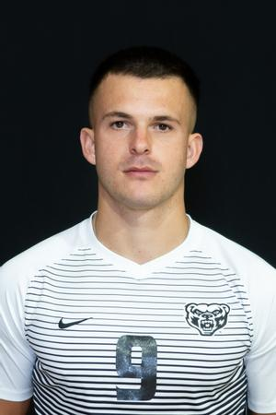  Contact  PHONE:  269-779-2762  WEBSITE:  Mikey Ketteman - Men's Soccer - Oakland University Athletics (goldengrizzlies.com)  EMAIL:  michaelketteman@oakland.edu  INSTAGRAM:  @_MIKEK9  HIGHLIGHT TAPE:  https://youtu.be/ZEDYNHOmP0Q?si=DAXKHw3ykM1Fj97Z |  | Michael Ketteman  Center Forward, American, 23  Accolades  2021 Season:  - Horizon League first team  - All North Region 3rd Team  2023 Season  - Horizon League Offensive Player of the Year  - Horizon League First Team  - Team Captain  - All North Region 2nd team  Career Statistics  - 21 Goals  - 8 Assists  https://unitedsoccercoaches.org/wp-content/uploads/2023/12/23-NCAA-D1-Mens-All-Region-Team.pdf  https://horizonleague.org/news/2023/11/3/mens-soccer-horizon-league-reveals-2023-hlmsoc-all-league-awards.aspx

