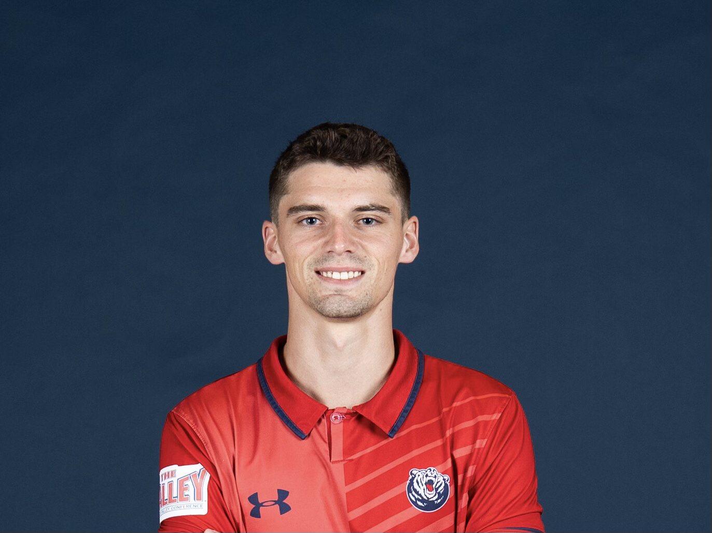 |  | Jansen Wilson
Contact  PHONE:  (270)401-5118  EMAIL:  19wilsja@gmail.com  Agent:  Cody Laurendi  PHONE:  (321)302-2273  EMAIL:  Claurendifcm@gmail.com  Highlight Video:  https://www.youtube.com/watch?v=jCmLa_o-9Ks  Awards:  - USYS National Semi-Finalist (Captain)  - Kentucky Gatorade Player of the Year  - Kentucky Youth Soccer POY  - 2021 CUSA Tournament Champion  - Back to Back round of 16 NCAA Tournament  - 2022 MVC 2nd Team  - 2023 MVC 2nd Team  - 2023 MVC All-Tournament Team  - Top Drawer soccer Team of the Week  - College Soccer News National Team of the Week  - MVC offensive player of the week  - 2023 season: 6G, 5A Total of 2 years at Belmont: 6G, 12A |  | Information:  DOB: 06/14/2001 (22 Years Old)  Position: Left Wing/ Attacking Midfielder/ Right Wing  Height/Weight: 5’11 / 155lbs  Nationality: American  Playing Experience:  Javanon FC  2006 – 2018  Reference:  Tim Chastonay  Phone: (502)930-3963  Email: tchastonay@bellarmine.edu  Columbus Crew SC  2018 – 2019  Reference:  Kelvin Jones  Phone: (757)345-1569  Email: KJones@columbuscrewsc.com  University of Kentucky  2019 – 2022  Reference:  Chase Wileman  Phone: (214)605-3239  Email: msoccer@brown.edu  Belmont University  2022 – 2023  Reference:  David Costa  Phone: (615)460-6134  Email: David.costa@belmont.edu

