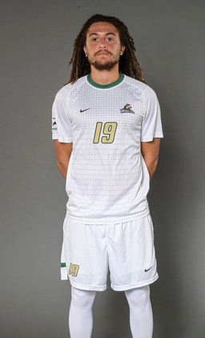
Daniel Bent
(706) 424-2288
Bentd002@me.com
Highlight Tape - https://youtu.be/HyQvI7GaTEI

Bio: D.O.B: January 10th, 1996

Height: 6’ 1” (185cm)

Weight: 184 lbs. (83kg)

Position: CB/RB

Experience: Gillingham FC (ENG League One) - 2013-15

Dayton Dutch Lions (PDL) - 2016

Columbus Crew u23 – 2017

South Carolina United Bantams (PDL) – 2018

Colleges: Reinhardt University - 2015-16

Wright State University (NCAA D1) - 2016-19
Defensive Player of the Year 2017
First Team All-League 2017
United Soccer Coaches Great Lakes Region Second Team 2017
First Team All-Ohio 2017
Defensive Player of the Year 2018
First Team All-League 2018
First Team All-Ohio 2018
United Soccer Coaches All-North Region First Team 2018
United Soccer Coaches Third Team All-American 2018
Top Drawer Top 100 Ranking - #36
Top Drawer Conference Top 20 - #1

References: Jake Slemker, Jacob.slemker@wright.edu, (937) 572-1777
Sid Van Druenen, sid.vanduenen@wright.edu, (937) 520-7188
Lee Morris, lee@southcarolinaunitedfc.com, (803) 521-2597
Scott Chalmers-Stevens, +44 (0) 7825093635
Pat Onstad, ponstad@columbuscrewsc.com, (614) 670-6441

