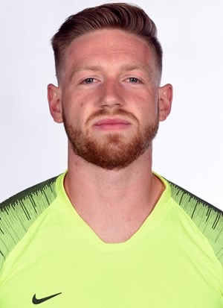
Domenic Nascimben
Cell: (412) 251-2251 Email: domenic.nascimben@gmail.com

Bio: DOB: September 27, 1997
Height: 6’ 1”
Weight: 195 lbs.
Position: Goalkeeper
Nationality: Australian & Green Card Pending

College: 2018-2022: Duquesne University (NCAA D1)
51 Appearances, 1 Assist
Final Stats (2022): Shutouts: 7
Save Percentage: .833 (6th Nationally)
Goals Against Average: .89
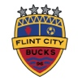
Experience: 2023: Flint City Bucks (USL2)
12 Appearances
6 Shutouts
Great Lakes Division Champions
Central Conference Champions
National Semifinalists (Final Four)

2023: Pittsburgh Riverhounds Training Player (USL Championship)
Players’ Shield Winners

2022: AHFC Royals/Brazos Valley Cavalry (USL2)
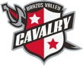
7 Appearances
Lone Star Division Champions

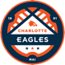
2021: Charlotte Eagles (USL2)
8 Appearances

2020: Pittsburgh Hotspurs (NPSL)
NPSL Members Cup, Midwest Rust Belt Champions (COVID)

Individual Honors: 2022:
College Soccer News National Team of the Week Aug. 29
Top Drawer Soccer National Team of the Week Sept. 13
Atlantic 10 Defensive Player of the week Sept. 12 & 19
Atlantic 10 (A-10) First Team All-Conference
Atlantic 10 (A-10) Academic All-Conference
United Soccer Coaches Third Team - All-Southeast Region

2021:
Ranked 2nd Nationally in NCAA D1 (Total Saves) with 98 overall
Ranked 12th Nationally in NCAA D1 (Saves P/G) with 5.16
Runner Up in Atlantic 10 Conference Tournament.
USL2 Save of the Week nomination in Week 10

2019:
Most Valuable Player for AFC Mobile
References:
Chase Brooks – Head Coach Duquesne Soccer (412) 694-2522. brooksc1@duq.edu
Adam Mitchell – Assistant Coach Duquesne Soccer (419) 554-0770. mitchella5@duq.edu
Keasel Broome – Goalkeeper Coach Duquesne Soccer (302) 507-2561. keaseljr@aol.com
Jon Busch – Goalkeeper Coach Pittsburgh Riverhounds (614) 774-7475.
Hunter Gilstrap – Goalkeeper Coach Pro Player Goalkeeping (412) 607-3313. info@proplayergk.com

