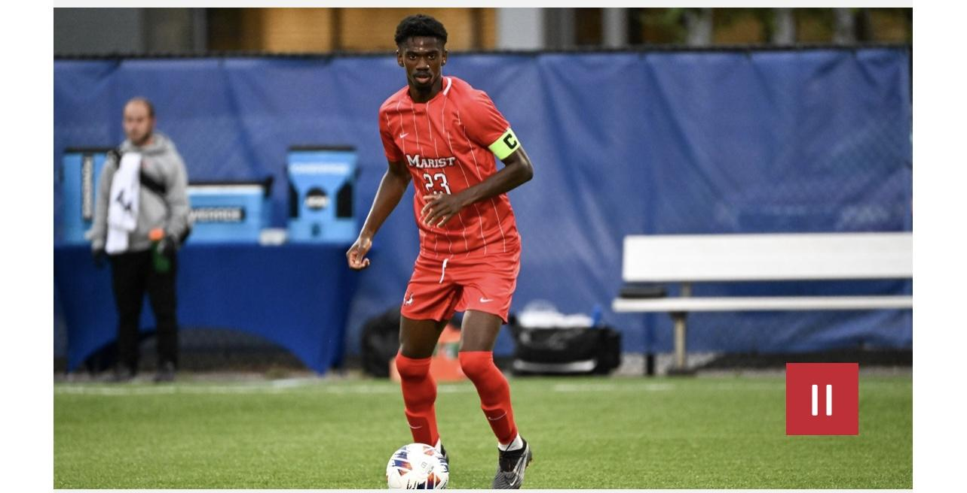

Demarre Montoute
Position: Center Back (preferred foot right)
Birth Date: March 3rd 2001
Nationality: Canadian
Height: 6’3
Weight: 175 LBS

Club/College History
Vaughan Soccer Club - CAN
Marshall University 2018 - 2019 (D1)
Marist College 2019 - 2023 (D1)

Strong, Athletic, Fierce, Warrior, and Fast Center Back
- Comfortable In Possession
- Excellent 1v1 Defender
- Pacey Center Back Can Run With Any Forward
- Dominants Arieal Duels
- Hard Nose Defender

Video: https://youtu.be/gvheIh8SNuY?si=r_47c9d03qgnEDvT

Accolades
- 2021- MAAC All Tournament Team
- 2022- MAAC All Third Team
- 2023- MAAC All Second Team
- Marshall University Regular Season and Conference Playoffs Champions 2019
- Marist College Regular Season and Conference Playoffs Champions 2021
- Eligible for Selection In MLS Super Draft 2024

