Curriculum Vitae
Personal Details
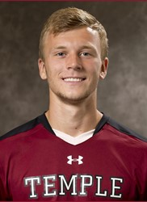
Name: Stefan Mueller
Date of Birth: October 13, 1995
Place of Birth: East Northport, New York
Nationality: American/German
Height: 6’2
Weight: 170lb
Position: Left Back
Preferred Foot: Left
Best Qualities: Crossing, 1v1 defending, ability to get into the attacking third frequently, first touch, physicality and pace
Highlight Video: https://www.youtube.com/watch?v=oHet8dek780
Contact: Phone: (631) 487-2776
Email: stefmueller26@gmail.com

Experience

Current Teams: Temple University (2013-2016)
- Started all 70 games of career
Pittsburgh Riverhounds u-23 (2016)
Past Teams: BW Gottschee Academy
NY Cosmos Academy
Long Island Rough Riders
Other Experience: Invited for 2 week trial with Fleetwood Town FC (League 1, England) offered spot on u-21 team
Invited to train with CD Alcala in Spain (January 2015 and January 2016)
Trained for 1 week with Pittsburgh Riverhounds during preseason (USL, United States) invited back to train for the summer (2016)

