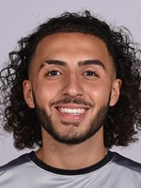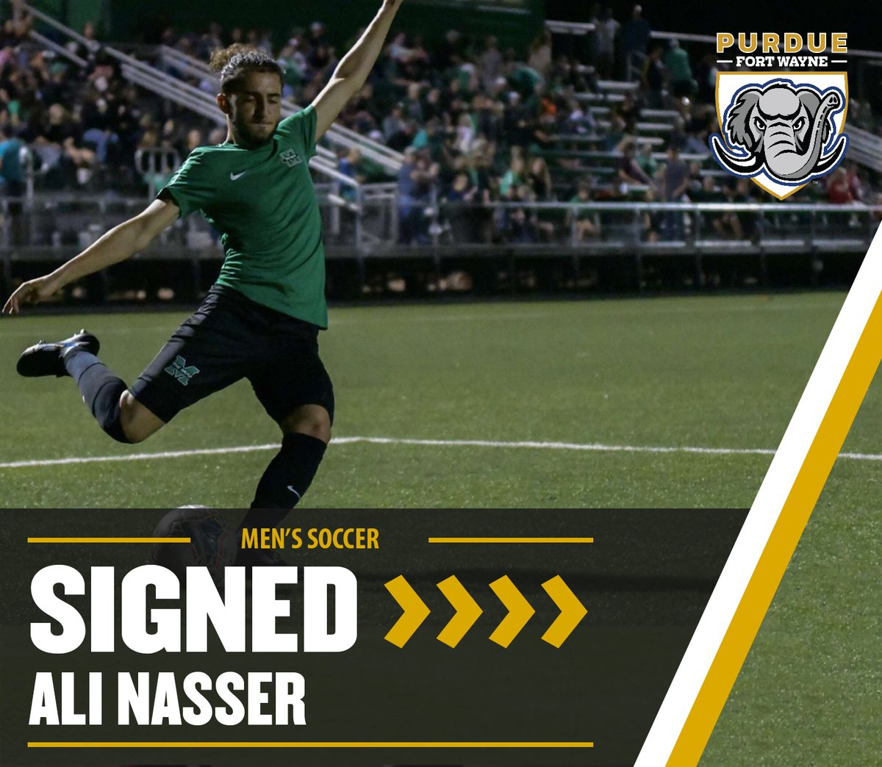

Ali Zolfikar Nasser

9911 Liberty Ct,
Dearborn, MI 48120
United States Of America
Alinasser23@live.com

Highlight tape
https://youtu.be/37V7sg6PFUw?si=RqetbqmCHEdKhq01

Soccer

2023 - Toledo Villa USL league 2. Number 10
10 games 6 goals 2 assists

2020-2023 Purdue Fort Wayne University Division 1 Soccer
Jersey 10 Midfielder/attacker

2021 Lebanese national team under 23’s played against the UAE in the UAE

2021. DCFC under 23s.

2019-2020 Marshall University #11 team rankled in all of USA
Jersey #22 Midfielder/Left back

2018-2019 Vardar Soccer Academy U19-Academy
Jersey #7- Coach Nathan Smith Midfielder

2017-2018 Vardar Soccer Academy U17- Academ Jersey #3- Coach Toni
Deacon Midfielder/Left back

2016-2017 Vardar Soccer Academy U16- Academy Jersey #15- Coach Toni Deacon Midfielder

2014-2016 AC Milan Club U13-U15
Jersey #10- Coach Francesco Ciao. Midfielder

2010-2014 Dearborn Mustangs U9-U12
Jersey #9-Coach Samir Bazzi Midfielder

Highlights
2020-2023 Purdue Fort Wayne University Division 1 soccer Fort Wayne, IN

2021- Lebanese national team under 23 call up Beirut, Lebanon

2019- Marshall University Division soccer Huntington, WV

2018- Coerver Performance Academy Brighton, MI

2017- West Ham United National Soccer Camp London, England

2016- USA Mens National Team Invite Michigan State, MI

2015- Super Y League Best 11 Team Bradenton, FL

2014- AC Milan 2nd Invite Milan, Italy

2013- AC Milan 1st Invite Milan, Italy

2012- Spain Tournament Barcelona, Spain

2011- ODP Regional 11 Pool player IMG, Florida

Personal Information
Date Of Birth February 7, 2001

Place Of Birth Dearborn, Michigan (USA)

Height 5’9

Weight 150 LB

Preferred Foot Right, good with left

