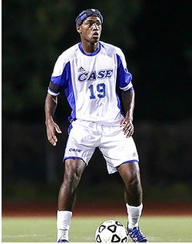
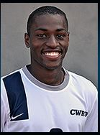
Taylor Fletcher
8902 Stones Throw Lane
Missouri City, Texas 77459
713-598-3651 (cell)
Taylorfletcher23@gmail.com

CLASS OF 2015
Height: 5’11”
Weight: 170 lbs.
Preferred Position: Right Back
Secondary Positions: Left Back, Center Back
Dominant Foot: Right
“Taylor is a tough, savvy defender who can play anywhere along the back line. He reads the game well and provides good cover for teammates. Taylor is an honest player that possesses all of the qualities that would make him successful at the professional level.”
BRANDON BIANCO, Head Coach, CWRU

"Taylor is a fantastic defender who possesses not only the ability to shut opponents down 1v1 but also the skill to get forward dangerously into the attack. He is athletic, fit, and strong, and his work ethic is exceptional."
CARTER POE, Head Coach, AFC Cleveland

Taylor is a proven leader. One of things which sets him apart is his fierce desire to win games and ability to elevate his teammates level of play.”

DAN PALMER Former Head Coach, CWRU

SOCCER EXPERIENCE

Michigan Bucks( PDL, Summer 2016)
- Member of the 2016 PDL National championship team
- Helped to Contribute to backline which conceded only 7 goals
AFC Cleveland (NPSL, Summer 2013-15)
- Saw time at outside back and outside mid
- 1 goal and 1 assist in 10 games
- One of very few DIII player on the team
Case Western – (DIII, University Athletic Association, ’11-‘14)
- Started in every game played in (52/52)
- 3-year starter at center-back; Team Captain 2013, 2014
- 2013– All UAA Conference Honorable Mention,
- 2014 – All UAA 2nd team
- 2g, 2a in career at CB
- Helped team to 1st NCAA post-season appearance in 7 years,
winning our first-round game against DePauw
American University – (D1, Patriot League. Fall of 2012)
- Appeared in two games
Eclipse Soccer Club – ‘92/93 Premier (Premier)
- Starting left defender after joining the team in 2009
- Region III President’s Cup Semi-Finalist, South Texas Champions 2010

Strake Jesuit College Preparatory – Texas (High School)
- Two-year Varsity Starter (2010, 2011); Second Team All-District 18-5A 2009, First Team All-District 2010
- State Runners up in 2010;Team posted record 27-1-1
- Texas Association of Soccer Coaches All-Region, All-State 2011
- First-Team All-State Tournament team, 2011 (state semi-finalists)
SOCCER REFERENCES:
Gary Parsons Director of Coaching, Michigan Bucks (PDL) 248-563-6691 parsons@oakland.edu
Carter Poe Head Coach, AFC Cleveland (NPSL) 440-667-4553 poecc@mountunion.edu
Brandon Bianco Head Coach, CWRU 614-314-4395 bxb318@case.edu
Dan Palmer Former Head Coach, CWRU 330-416-7237 dpalmer@oberlin.edu
Highlight Video:
https://www.youtube.com/watch?v=UvfdmmM8hZs

