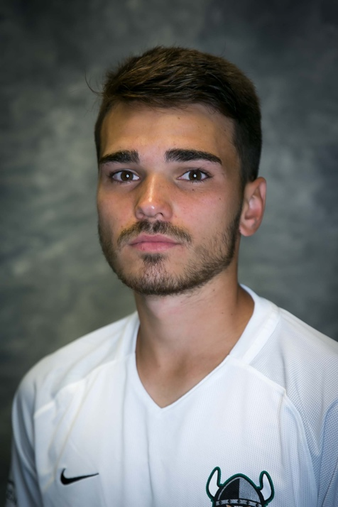
tHomas Bielanski
thomasbielanski4@gmail.com
(216) 526- 8429

BIO
DOB: May 19, 1998
Height: 5’6.5”
Weight: 140 lbs.
Preferred Foot: Right
Position: CDM/ CM

Experience

2016-2019: Cleveland State University (NCAA Division 1)
Captain
3 Goals, 6 Assists
45 Games Started
53 Games Played

2014- 2015: Vaughan SC (Canadian Club)
Ontario Cup Winner x3
Disney Showcase Winner
6 Goals, 15 Assists
35 Games Started
40 Games Played

References:
Cleveland State University Head Coach: 2019- Present: Sinsia Ubiparipovic Email: S.ubiparipovic81@csuohio.edu Cell: (440) 749- 0367
Cleveland State University Head Coach: 2016-2019: Kirk Harwat
Cell: (216) 310- 2495
Vaughan SC Head Coach: Patrice Gheisar
Cell: (416) 318- 2409

