Jake Leeker | Phone: (314) 957-8435 | leeker@sbcglobal.net
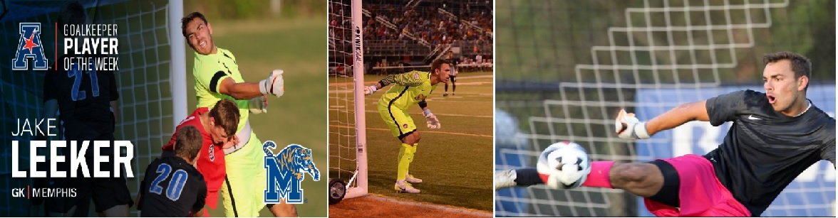

Bio DOB: June 14, 1995 Height: 6’5 (195 cm)
Preferred Foot: Right Weight: 210 lbs (95 kg)
Position: Goal Keeper

Experience 2017: University of Memphis D1 (AAC Division) – The Fall season currently in progress
2017: Des Moines Menace (PDL Heartland Division)
Played in several games with a GAA 1.33

2016: University of Memphis D1 (AAC Division)
GP 17 / Minutes 1536 / Saves 74 / Save % .747 / Shutouts 6 /GAA 1.46
Three-time AAC Goalkeeper of the Week
Defensive player of the year award (included all sports at University of Memphis)
2016: De Moines Menace (PDL Heartland Division)
Played in several games with a GAA 1.00

2015: University of Memphis D1 (AAC Division)
GP 11 / Minutes 1065 / Saves 49 /Save % .754 /GAA 1.35
Two-time AAC Goalkeeper of the Week

2014: University of Memphis D1 (AAC Division)
GP 3 / Minutes 68 / Saves 5 / GAA 1.35 / Shutouts 2

2011 -2012: United States Development Academy (St. Louis Scott Gallagher)
GP 19 / .64 GAA / Shutouts 7
Top Drawer Soccer Best Goal Keeper during Development Academy Playoffs
Started in Development Academy championship game against the Red Bulls

References: De Moines Menace (PDL) Head Coach: John Pascarella
John.pascarella@outlook.com phone: (703) 851-2528

University of Memphis Head Coach: Richard Mulrooney
rmulrony@memphis.edu , phone: (901) 678-4141

St. Louis Scott Gallagher Director of Goalkeeping: Tim Kelly
tkelyslsgsoccer@gmail.com , phone: (636) 448-3200

Highlight Video: https://youtu.be/s4jTqBLoA9I

