Alexis Souahy

DOB: 01/13/1995
Position: Right Back/Center back
Height & Weight: 6’1 & 175 lbs.
Nationality: French

Attributes
References

Jerome Meary - Agent
Former MLS Player Department
+1 718 496 0145

Eric Nichols – Head Coach
+1 614 657 3977

Gary Parsons – Director of Coaching
+1 248 563 6691
Demir Muftari – Head Coach
+1 248 321 2245

Frederik Lipka – MLS Technical Director of Player Youth & Development
Former Le Havre AC academy director
+1 917 225 6612
Right foot
1v1
Aerial duels
Passing
Leadership
Placement

Bowling Green State University
Senior captain
Started and played every game
2017 All-MAC team

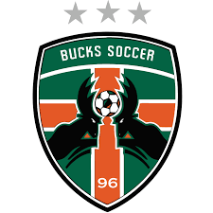
Michigan Bucks - PDL
2017 Conference Champion
Started and played every game

2016 National Champion
2016 Conference Champion

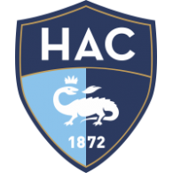
Le Havre Athletic Club (Pro D2)
Played in U17 – U19
Played with the reserve team

