Fauris Franco
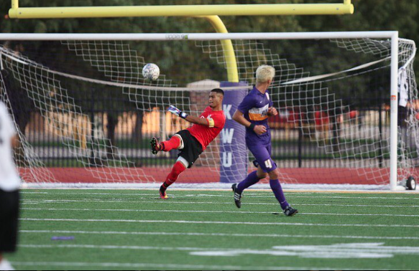

Hometown - San Francisco, CA
Nationality – Guatemala
DOB – 11/7/1994
Position – Goalkeeper
Height – 6’0ft
Weight – 178
Contact – 415-299-7911
Email – Fauris94@yahoo.com

College Level
- 2 years at Skyline Community College
1st year 2nd team all conference
2nd year Team Captain, Teams MVP, 1st team all conference
- Current Senior at Kansas Wesleyan University - NAIA KCAC Conference

Junior Year 2015 Season
KCAC All conference
Teams defensive most outstanding player
Teams Most Value Player

Senior year 2016 Season
Defensive Player of the week – Sept. 26 – October 2
Defensive Player of the week – October 10 – 16
1st Team unanimous selection

Club Level
Juventuds 94 Primer
2013 Dallas Cup Tournament, NorCal State Cup 2013, 2013 Juventuds Spring Showcase (Champs)
G.I.M.S
State Cup, SF Cup, 2012 Juventuds Showcase

References

Sean Geoghegan – Goalkeeper Coach KWU – (917) 593-1367
Philp Bohn – Head Coach KWU – (612) 386- 7476
Daniel Link – Head Coach Skyline College – (415) 244-6186

