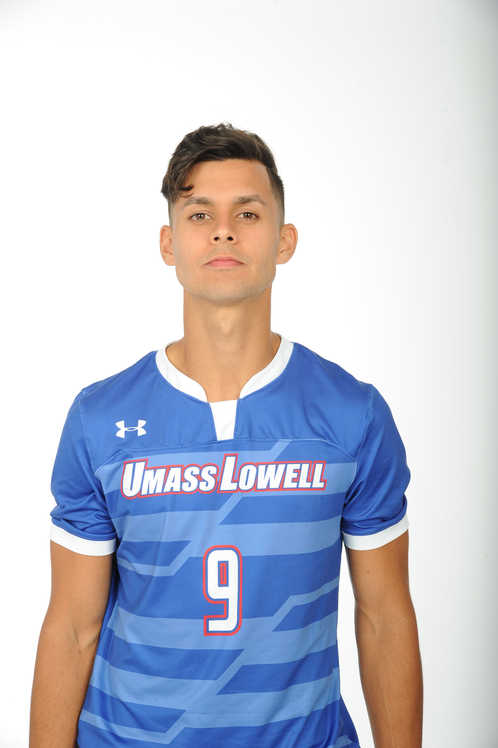
Stanley Alves

ADDRESS: 54-56 Gilbert St Watertown, MA 02472
Cell: (USA) +1 617-593-2497 EMAIL: stanley.alv9@gmail.com

Bio: Strengths:
- D.O.B: 6/30/1996 - Movement off ball
- Height 6’1” (1.85 M) - Finishing/ Technical ability
- Weight 170 lbs. (77 kg) - Hold up play
- Right Footed - Defensive work rate/ Fitness
- Mentality/ Attitude

Pro Career:
- U-23 New England Revolution (MLS, 2019)
4 goals + 2 assists in 7 matches.
Consistently trained with 1st team.
- Trained with Sertanense F.C. (Campeonato de Portugal, 2018)
- Trained with Sport União Sintrense (Campeonato de Portugal, 2018)
- Captained Umass Lowell (NCAA DI, 2018-2019)
All-North East Region 2nd Team + All-Conference 1st Team
19 goals + 6 assists in 34 matches.
References: Video Link: https://www.youtube.com/watch?v=I-c12zYqCtQ
-Christian Figueroa: Umass Lowell
Phone: 508-265-7222 Email: christian_figeueroa@uml.edu
- Franky D’Agostino: Harvard
Phone: 413-362-2254 Email: dagostfg@gmail.com
Passports:
-Brazil
-United States of America

