Andrew Gold  Defender  May 2019, DePauw University | 1005 Hawthorne Drive  Columbus, IN 47203  812-350-0202  Arg1005@gmail.com

OBJECTIVE: To identify the best fit for my post-collegiate soccer career.

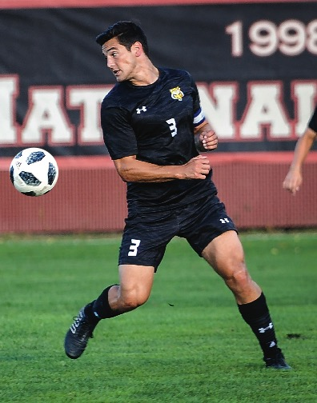  2x Captain, 3x all conference, 28 career shutouts | ACADEMICS:  - Overall GPA: 3.31/4.0  - Majors: English Writing, Psychology  - Interned with Dr. Rob Bell, mental toughness coach  - Played for 3 weeks in Italy January 2017  ATHLETICS:  - Height: 6’0”  - Weight: 195 lbs  - Right-footed  - Strength: speed, strength, agility, communication, aerial ability, individual defending, team defending  - College: DePauw University  - Coach: Brad Hauter 317-417-9216  - bradhauter@depauw.edu
SOCCER ACCOMPLISHMENTS:  2018-2019  - Captain, Team MVP  - Appeared and started in all 18 games  - Recorded one goal (1 GW), one assist  - All-NCAC First Team  - All Great Lakes Region 2nd Team  2017-18:  - Captain as a Junior  - Appeared and started in all 16 games  - All-NCAC Second Team  - Recorded 2 goals (2 GW) and one assist  2016-17:  - Appeared and started in 18 games  - Recorded two goals (2 GW) and one assist  - All-NCAC First Team  - Round of 32 NCAA tournament  2015-16:  - Appeared and started in all 21 games  - Recorded one assist  - Sweet 16 NCAA tournament | HIGHLIGHTS: http://www.hudl.com/v/2AqVJt  Bridges FC: Summer 2019  Brett Hall: (847-489-4012)

