Profile: Miguel Yuste
Valladolid, Spain (4/2/1997)
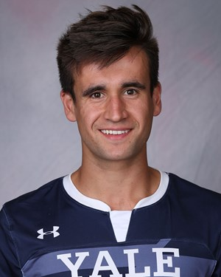
Attacking midfielder.
Also: Center midfielder, outside midfielder

Description:
Creative midfielder with good vision, technique, and drive in the final third.
He has the ability to create chances, score goals, and assist others.
He understands and reads the game very well.

Highlight video:
https://www.youtube.com/watch?v=KliwoKhWAg4&t=44s

Background:

Yale
- In college, Miguel played at Yale University and was named the 2019 team captain. As an attacking midfielder, he lead the Ivy League with 8 goals and also added 4 assists his senior year. He was named to the Ivy League First Team and the All Northeast Region First Team. Ivy League Champion as a senior for the first time in school history since 1991.

Northfield Mount Hermon School
- Played and captained two seasons at Northfield Mount Hermon, ranked in the top five in the nation both years. Named NEPSAC Offensive Player of the Year as a senior. Scored 28 goals and had 22 assists in his two seasons. Two-time team captain, all-state and WNEPSSA All Star and twice named to WNEPSSA Select team. Team MVP as senior. NMH posted a 30-7-1 overall and reached the Class A New England Championship finals both years.

Real Valladolid C.F. S.A.D.
- Played for Professional Youth Academy Real Valladolid C.F. in Spain since he was 12 years old until he was 17 (Infantil, Cadete, Juvenil). 3-time team captain.

