Paul Hoffmeister Football CV
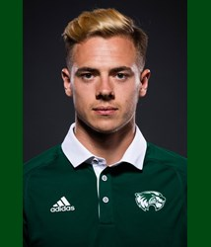
General Info
Height: 5’ 11
Weight: 172 lbs.
Position: Winger, Offensive Midfield
Graduation Date: December 2016
Cumulative GPA: 3.95
College: Utah Valley University
Always been a starter since my freshman year
finished 2016 season with 9 goals and 3 assists

2016 - Honors
NSCAA NCAA Athletic All-American - Third Team
CoSIDA Academic All-American - Second Team
All-West Region - First Team
All-WAC - First Team
CoSIDA Academic All District 8 Team

All-time single season:
leading goal scorer for UVU
most points for UVU

TopDrawerSoccer.com Team of the Week on two separate occasions
College Soccer News’ National Team of the Week
TopDrawerSoccer.com Top 100 college players (No 87)
Academic All-WAC

2015 - Honors
All-WAC - Second Team
Single season: Second most goals for UVU
CoSIDA Academic All District 8 Team
Academic All-WAC

TEAM Awards:
WAC Regular Season Champions 2016
NCAA tournament appearance 2015

Link to roster: http://wolverinegreen.com/roster.aspx?rp_id=4430&path=msoc

