Mitchell Cardenas
Player CV

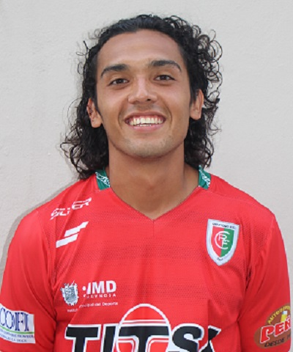

Position: Midfielder
Born/Nacio: 1-8-91 (26 yrs. Old) Mexico City, Mexico
Height/Estatura: 6ft 1in. 1.84m
Weight/Peso: 174 lbs.
Passport Info/Info Legal: Pasaporte Mexicano. Pasaporte Americano

TRAYECTORIA
- Houston Dynamo Academy/ Texas Rush Academy
- Campbell University
- PDL IMG Academics 2011, PDL Houston Dutchlions
- Sporting Kansas City in the MLS Supplemental Draft 2013
- Pumas Morelos 1A Ascenso Liga MX 2013
- Delfines Atletico Coatzacoalcos Segunda Division Liga MX 2013/14
- Reynosa F.C. Segunda Division liga MX 2014/15
- Club de Futbol Sacachispas Primera Division Guatemala 2015
- Dutch Lions F.C. NPSL 2016
- BV Cavalry PDL 2017
- GIF Sweden 2017
Links
Bio 2012 (Prior to senior season) http://www.gocamels.com/sports/msoc/2012-13/bios/cardenas_mitchell_ufb7
Videos
http://www.youtube.com/watch?v=jZcP2eGXy7g (College highlights video link/Video Cortos Accion) 2013
http://www.mlssoccer.com/video/2012/12/27/mls-superdraft-mitchell-cardenas-camp (MLS Draft Video) 2013
https://vimeopro.com/texasrushipd/mitchell-cardenas password: MCARDENAS (2015)
https://www.youtube.com/watch?v=8J12L0mQ6eM 2016
Trajectory/Trayectoria Pictures/Fotos
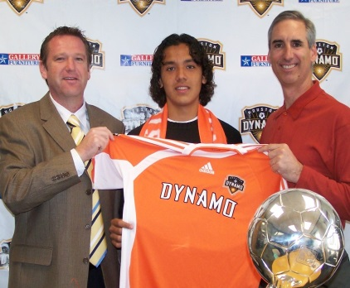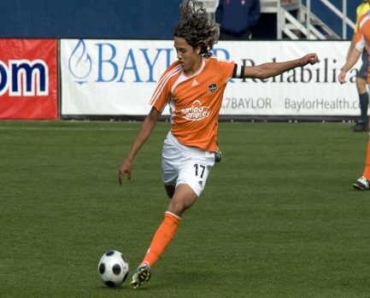
Houston Dynamo Academy 2007-2009

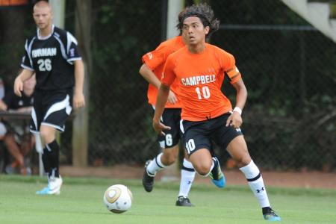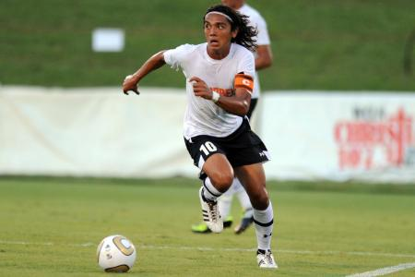
Campbell University/ Universidad de Campbell 2009-2012
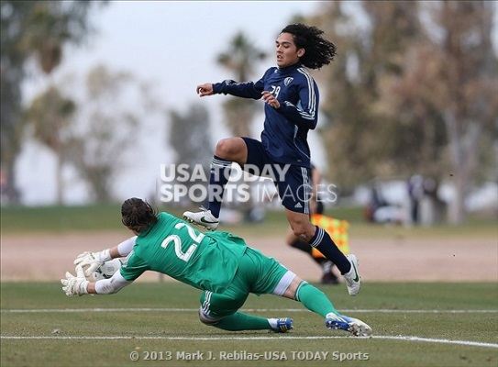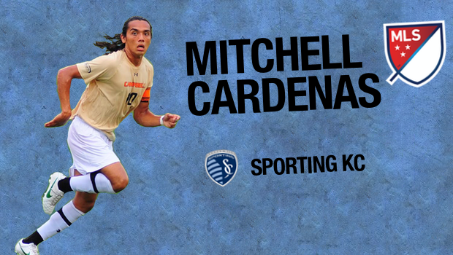
Sporting KC Supplemental Draft 2013
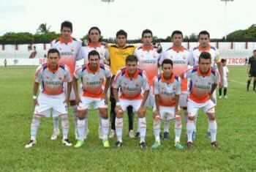
Atletico Coatzacoalcos 2013-2014
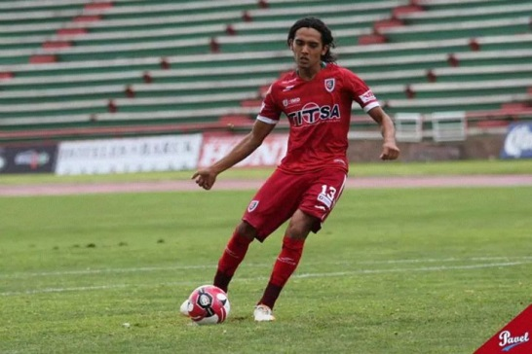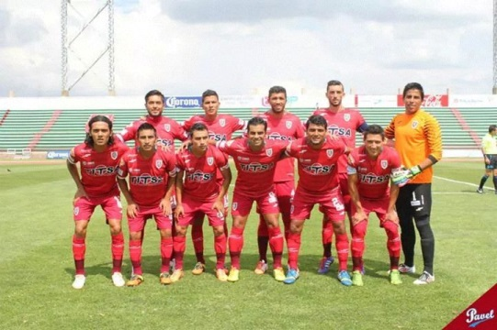
Reynosa F.C. 2014/15
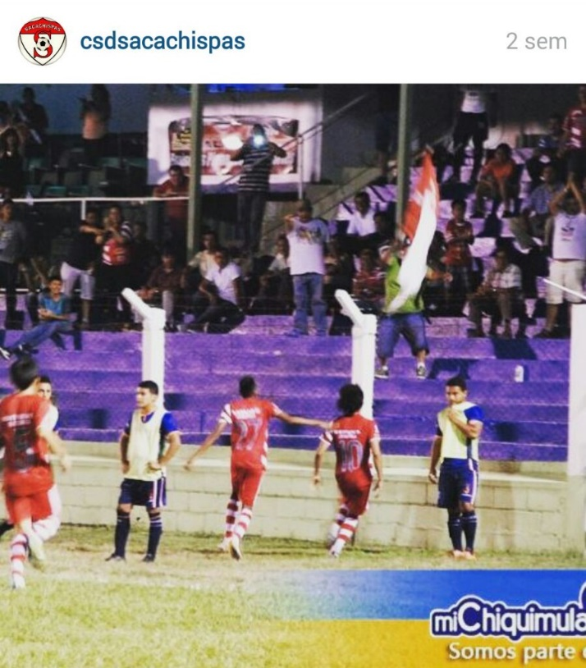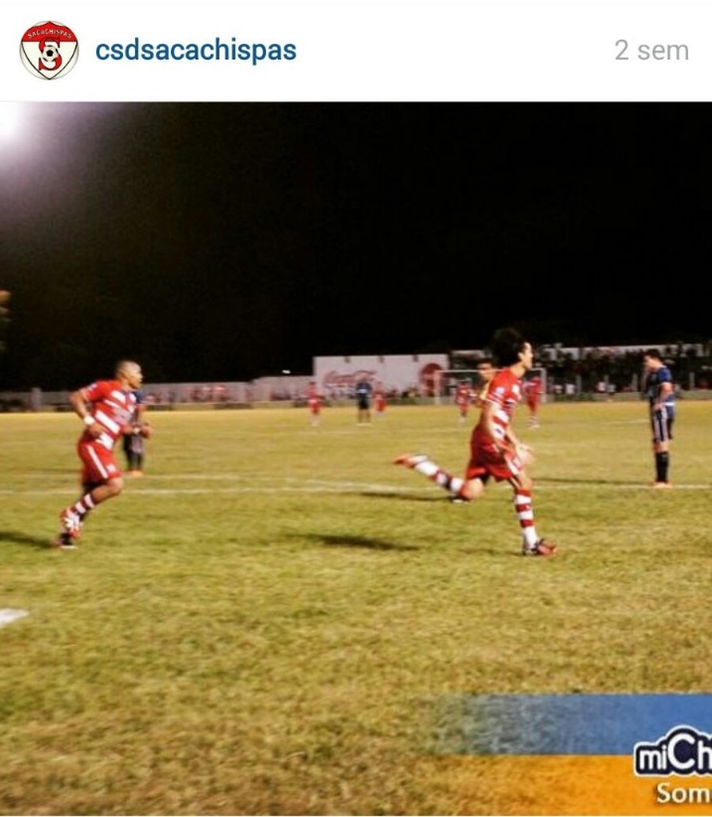

Club Social y Deportivo Sacachispas 2015
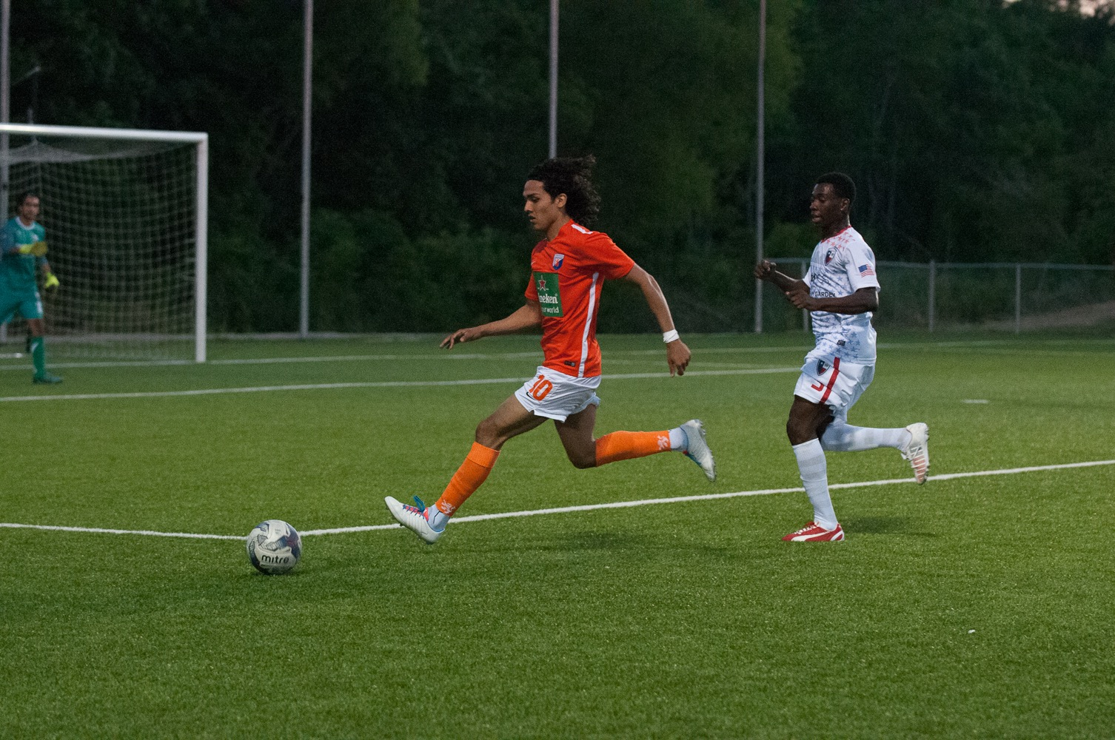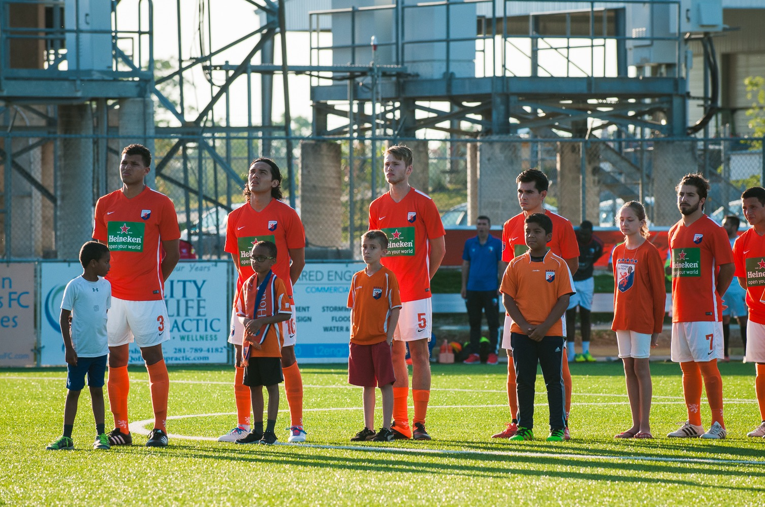
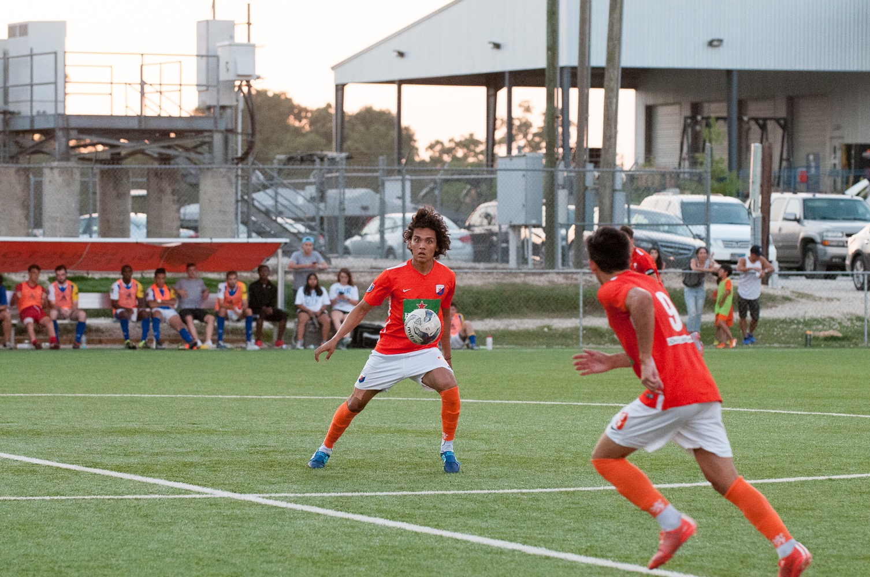
Houston Dutch Lions NPSL 2016
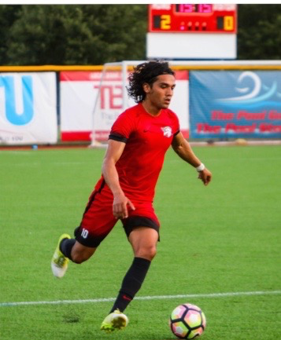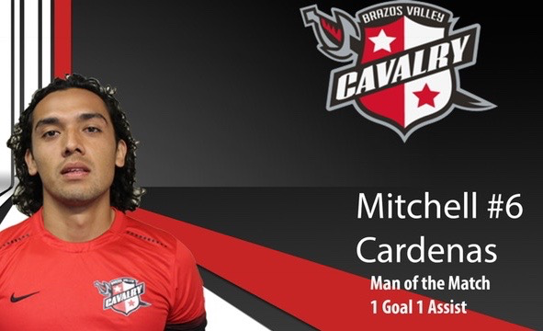
http://bvcavalryfc.com/news/?article_id=17
Brazos Valley Cavalry PDL 2017
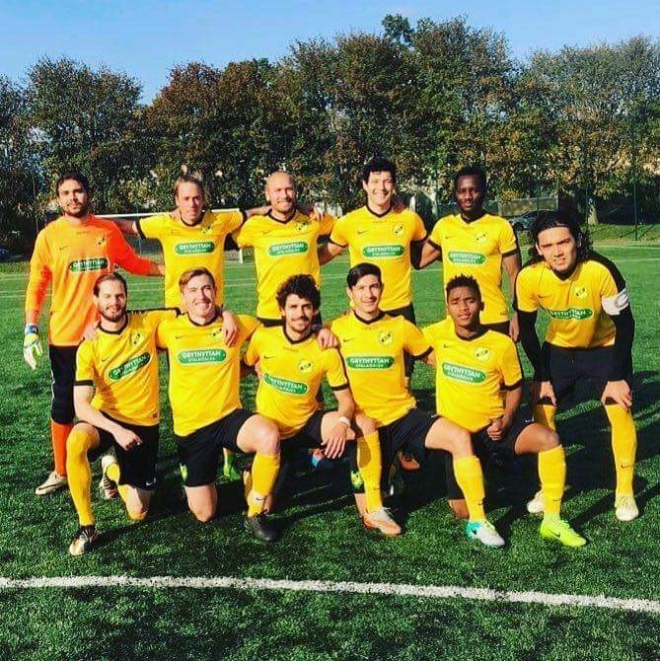
Grythyttan IF Sweden 2017
References:
Kaj Nassen: General Manager, Grythyttan IF. Email: volume15@hotmail.com
Steve Armas: Assistant Coach, Wake Forest University. Email: armasas@wfu.edu Phone: 336-758-5516
Joe Funicello: Owner & Head Scout, Soccer Viza. Email: joe@soccerviza.com Phone: 757-450-2862
Marco Pruis: Head Coach, Houston Dutch Lions NPSL. Email: m.pruis@hdlfc.com Phone: 713-498-3888

Mitchell Alejandro Cardenas
Email: m_cardenas17@hotmail.com
USA Cell: 713-371-6171

