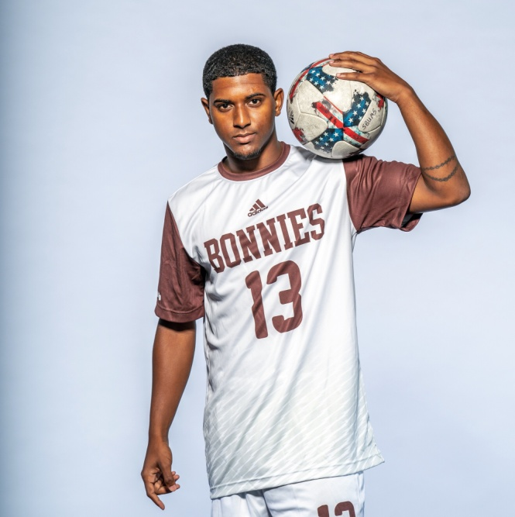
JON-MICHAEL PERKINS
Cell: 716-378-4954
Email: jm_perkins@hotmail.com

BIO: D.O.B: January 15th 1998
Nationality: Jamaican/Canadian
Height: 5’9” (175cm)
Weight: 160lbs (73kg)
Preferred Foot: Right Foot
Primary Position: Right Back
Secondary Positions: Left Back, Winger

Strengths
A speedy 2-way fullback that always looks to join the attack without neglecting defensive responsibilities. Excellent 1v1 defending skills, Speed and dribbling skills allows me to beat players and deliver crosses into the box.
Experience
2016-2019 - St. Bonaventure University (NCAA Division 1 – Atlantic 10 Conference)
2018 – North County United (USL League Two/USA 4th Division)
2017 – FC Boulder (USL League Two/USA 4th Division)
2016 – North Toronto Nitros (League1 Ontario/Canada 2nd Division)
2016 – Jamaican U20 Men’s National Team Training Camp
2014/2015 – Jamaican U17 Men’s National Team Training Camp
References
Luis Swisher, Former FC Boulder Head Coach & USL Scout. 202-674-0167
Kwame Oduro, St. Bonaventure Head Coach. 517-763-9010

