Jarred Johnathon Dass
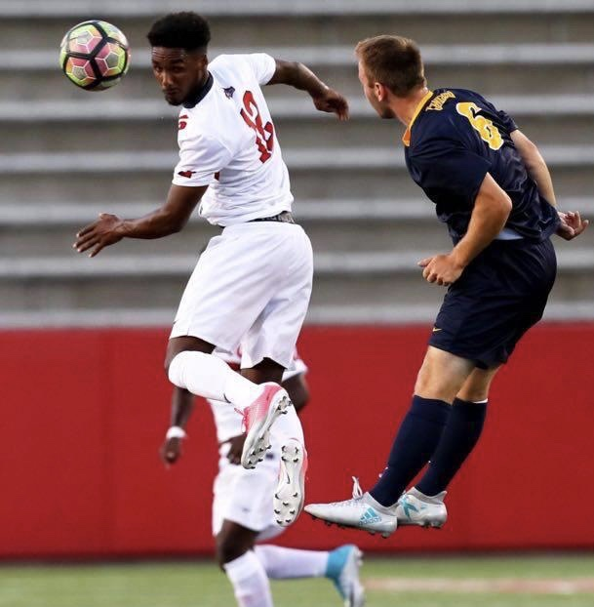
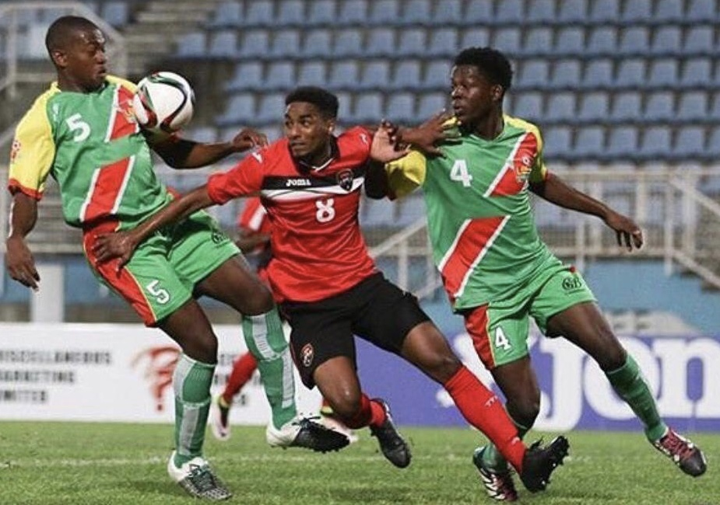

Date of Birth: December 01st 1997
Height: 5’11” Weight: 160lbs

Most Played position: Attacking Midfielder/Winger/Striker
Other positions played: Defensive Midfield

Email Address: dass.jarreddass@hotmail.com
Telephone contact: +1 (305) 713 9597 or +1 (868) 680 7624

AFC Ann Arbor – NPSL, Michigan (Summer League 2019)
To date – 3 goals, 3 assist

Stony Brook University (Senior) – New York, USA
- Men’s Soccer team, 14 goals, 3 assists
- America East All Conference Second Team - 2019
- America East All Conference First Team - 2018
- All Star Rookie Conference Team-2016

Trinidad and Tobago National U-21 Player
- Central American and Caribbean Games – July 17th - August 2nd, 2018

Trinidad and Tobago National U-20 Player
- CARIBBEAN FOOTBALL UNION (CFU) Tournament - June 15-19, 2016
- International Caps – 3, Goals: 1, 1 assist

Trinidad and Tobago National U-17 Player

  - International Caps - 7, Goals 2
  - CONCACAF WORLD CUP Qualifying Tournament Panama – April 2013
  - USA Tour - March 2013
  - Costa Rica Tour - February 2013
  - Colombia Tour - December 2012
  - CFU Tournament – July 2012

W Connection FC: Pro League Youth
  - U-18 Player - 2nd Place in Division: Trinidad and Tobago National Pro League Youth 2014
  - U-17 Player - (Most of season spent with Trinidad & Tobago National U-17 Team) 2013
  - U-16 Player - 1st Place in Division: Trinidad and Tobago National Pro League Youth 2012
  - U-15 Player - 1st Place in Division: Trinidad and Tobago National Pro League Youth 2011
  - U-14 Player - 1st Place in Division: Trinidad and Tobago National Pro League Youth 2010

Naparima College:
  - Barbados Cup - Tournament Champions April 2014
  - Championship Team - 2011 - 2015
  - U- 16 Captain - National Champions 2013
  - U-14 Captain - National Champions 2011

SPORT ACCOLADES - (Football)

- Secondary School Football League Top Five Players of the year – 2015
- Secondary School Football League All Stars Team - 2015
- Club Sando U-14 Captain - 2nd place: Trinidad and Tobago Super League 2010
- Southern Football Association Centre for Excellence Grade “A” Evaluation 2009
  - Most Outstanding Player
- Southern Football Association Centre for Excellence Participation 2008
  - Most Valuable Player 2008
- SKHY Football/Soccer Summer Camp
  - Most Valuable Player 2008

- Digicel/Manchester United &La Foucade International Football Camp
    - Most Valuable Player 2007
- SKHY Football Summer Camp
    - Most Valuable Player (8 - 10) 2007
- Dunstan Williams Football Academy - 2006
    - Certificate of Participation
- SportWorld/ InterMilan & La Foucade Football Clinic - 2006
    - Certificate of Participation

SPORT- (Swimming)

- School Zonal Swimming Competition - Certificate of Participation 2009/2010

SPORT- (Miscellaneous)

- School Sports Day Marathon - 1st Place (U14 - Flemington House 2010)
- Victoria Zonal Track and Field Championships - Bronze medal 4 X100 relay 2011
- Hampton Games 150 meters - Bronze medal 2005

ACADEMIC & EXTRA CURRICULUM ACTIVITIES:

- Stony Brook University, New York
  - Senior, completing degree in Marketing- Dec2019

- Form 6 Cape I Exams June 2015

- Form 5 CXC Exams - June 2014

- The Oratory Foundation Certificate for completion (Oratorian Teenagers)

    - Choral speaking, poetry writing and performance - September 2010

- The Oratory Foundation Certificate for completion (Advanced Teenagers)

    - Choral speaking, poetry writing and performance - March 2010

- The Oratory Foundation Certificate of merit (Preliminary Teenagers)

    - Choral speaking, dramatic monologues, poetry writing and performance - January 2010

- The N.E.C Certificate of Performance, Introduction to Computers - 2008/2009

- Living Waters Community Youth Group Member - 2011

REFERENCES:

Ann Arbor FC, Michigan Head Coach: Eric Rudland +1 (734) 408 1627
Stony Brook University Head Coach: Ryan Anatol +1(813) 956 0432
National U-23 Football Head Coach: Angus Eve +1 (868) 785 4140
National U-21 Football Head Coach: Mr. Russel Latapy +1 (868)462 1010
National U-20 Football Head Coach: Mr. Brian Williams +1 (868) 688 9919
National U-17 Football Head Coach: Mr. Shawn Cooper +1 (868) 745 2728
National U-15 Football Head Coach: Mr. Shawn Cooper +1 (868) 745 2728

