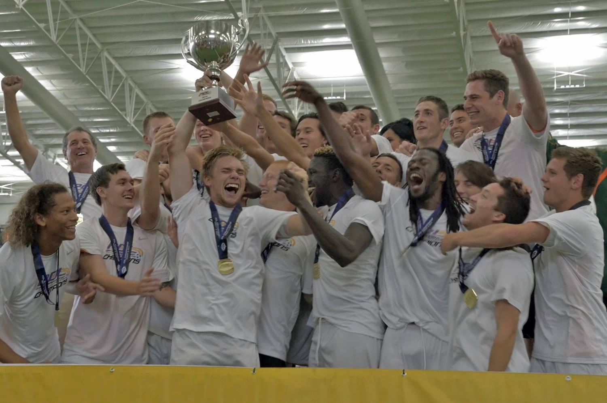
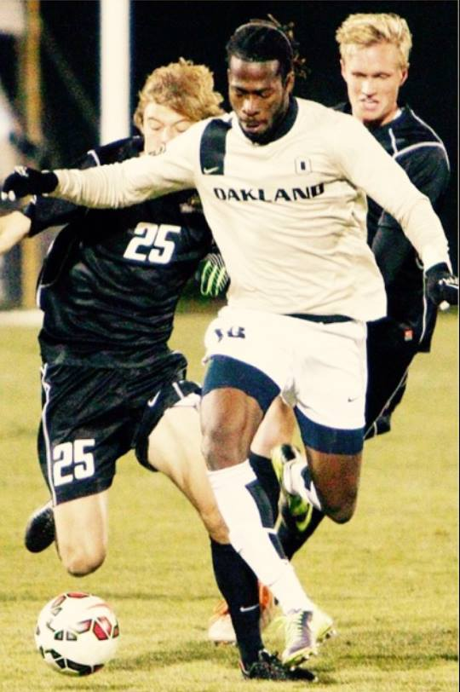
Gerald Ben Email: bengerald007@gmail.com
Day of Birth 12/31/1992 (23 years old)
6’3 180
Liberian, American citizen
Positions- Striker, Left and Right Winger
Club Football
Minnesota Thunder Academy 2007-2010
Was the leading scorer on the club from 07-10
Leading scorer in the Mid-American Division Academy League with 13 goals in 21 games
Academy Showcase 2011 3 games 3 goals
High School Football
Prairie Seeds Academy 09-11
Junior year scored 15 goals in 10 games.
Senior year scored 39 goals with 15 assist in 22 games.
Won state championship, scored the game winner in double over time
Minnesota All state player
Team went undefeated
Espn Minnesota All American
College Football
North Iowa Area Community College. Head coach- Mike Regan Cell: 319-830-5773
Freshman year North Iowa Area Community College
14 goals in 21 games. 8 assist
Conference player of the year
Leading Score
Player of the year on my team
All region player
All American nominee
Sophomore Year
Westmont College. Head Coach- Dave Wolf Cell. Head Coach- Dave Wolf Cell: 805-455-3244
13 goals and 5 assist in 15 games
Player of the week October 8, 2012
Leading Score
All gsac player
Oakland University (Junior and Senior Year)
Head Coach- Eric Pogue- 248-894-9198 Stephen Gorton- 620-290-1027 Andy Wagstaff- 248-790-9226 Steve Seargeant- Played for Everton FC
Junior Year
Horizon League Tournament MVP
4 goals, 3 assist
College starting XI Nov. 17, 2014
Horizon League Regular Champs and Tournament Champs
Team went to the second round of the national tournament

Senior Year
Won horizon League Tournament back to back (1st in history)
NCAA national tournament 1st round
5 goals

Michigan Bucks- Professional Development League (PDL) Summer 13-15 Head Coach- Demir Muftari- 248-321-2245 Dan Duggan- 216-533-0757 Gary Parson- 248-563-6691
Summer 13
8 goals, 3 assist in 11 games
PDL Player of the week. June 20th 2013
Team of the week. June 20th 2013
Summer 14
2 goals, 5 assist (Tied for 3rd in the PDL with assist)
Won the PDL national championship
Summer 15
1 goal, 2 assist
Named to top 50 PDL prospects
2016
Trained with HB KØGE (Danish 1st division)
Signed with Swedish 2nd division Ånge IF (second part of the season)

Highlight Video
Was invited to the Tourbeau Pro Soccer Combine held on December 4-7, 2012 in Orange Beach, Alabama. (Was unable to attend due to exams)
http://www.youtube.com/watch?v=x_cR17BxO8Y
http://www.youtube.com/watch?v=4m7LIARcmfg (I scored the first goal)
http://www.youtube.com/watch?v=bT0ATtRvuBE
https://www.youtube.com/watch?v=6RkPKZ0UPgc (Newest Video)

