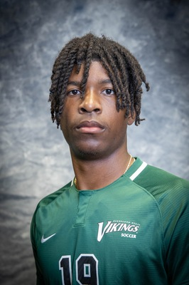
Gabriel Pewu
(216-205-2862)
gpewu11@gmail.com

Bio DOB: 09/16/1998
Height: 6” 04” (193cm)
Weight: 193 lbs (87kg)
Preferred Foot: Right
Position: CF/ST

College 2016-2019: Cleveland State University (NCAA D1)
18 goals, 3 assist, 39 points, 64 appearances
First Team All-Horizon League
Third Team All-Region
Top 10 in Division I for Shot Accuracy
2x Horizon League Player of the Week
Most Game-Winning Goals in Horizon League for 2019 regular season

Experience 2019: Dayton Dutch Lions (USL League Two)
2 goals, 1 assist, 9 appearances

References CSU Head Coach: Siniša Ubiparipović, s.ubiparipovic@csuohio.edu, (440)-749-0367
Former CSU Head Coach: Kirk Harwat, k.harwat@csuohio.edu, (216)-310-2495

