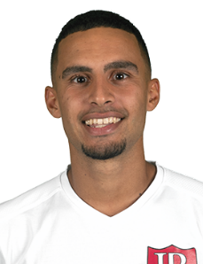  Bio  Birthday: 25 December 1995  Position: Left/Right Winger  Hometown: Lisbon, Portugal  Height: 5’7’’ (170cm)  Weight: 138lbs (63kg)  achievements  - National Champion South Division (2011/2012)  - NCAA DII Round of 16 (2017/2018)  - GMAC conference Champion (2017/2018)  - SAC Conference Champion (2018/2019)  - SAC Conference All-Tournament team (2019)  - USL2 Eastern Conference Champion (2019),  - USL2 National Finalist (2019),  - SAC Honorable Mention (2019) | Gonçalo Garcia  +16465959946 | goncalocmgarcia@gmail.com  https://www.youtube.com/watch?v=b_zTQK71ZP0&t=30s  BAckground  2002–2007  • Clube Desportivo Olivais e Moscavide U12 (Portugal)  2007–2010  • Sport Grupo Sacavenense U15 (Portugal)  2010–2013  • Casa Pia Atlético Clube U18 (Portugal)  2013–2014  • Atlético Clube de Portugal U19 (Portugal)  2014–2015  • Odivelas SAD (Portugal)  2015–2017  • União Atlético Povoense (Portugal)  2017–2018  • Ohio Valley University (USA)  2018–2019  • Lenoir-Rhyne University (USA)  2019  • Reading United AC (USA)  Social MEdia  Youtube: https://www.youtube.com/channel/UCrMCnFb8cfv_kARFQDxJ9EQ  Linkedin: www.linkedin.com/in/gonçalo-garcia-b74295187  Instagram: @goncalocmgarcia  Twitter: @GoncaloGarcia10

