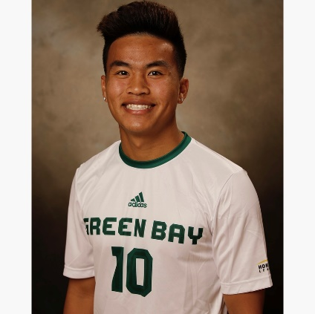
Brian Vang
Date of Birth: 3/17/1998
brianvang5@icloud.com
763-312-0773

Status
Junior, University of Wisconsin-Green Bay/ NCAA Division 1, Class of 2020
Position
Midfielder: 8, 6
Club Experience
Teams:
- Flint City Bucks, PDL Summer 2019
- Western Mass Pioneers, PDL Summer 2018
- Minnesota Thunder Academy U16-U18 Development Academy(2014-2016)
- Minnesota Thunder Academy U12, U13 and U14
- St. Paul United U9-U11
European Clubs
- AC Ajaccio, France 2018
- West Ham United, in Georgia 2011
- West Ham United, in England 2012
Awards and Achievements
- Full time starter for University of Wisconsin-Green Bay (Freshman, Sophomore, Junior, and Senior Seasons)
- Full Time Starter for Western Mass Pioneers, PDL Summer 2018
- 1x Horizon League Champion (NCAA Division1)
- 2011 Minnesota State Cup Winner with Minnesota Thunder Academy
- Most Valuable Player at GT Soccer Camp 2010
- 2x Schwan’s USA Cup Winner

College
- Played for University of Wisconsin-Green Bay

