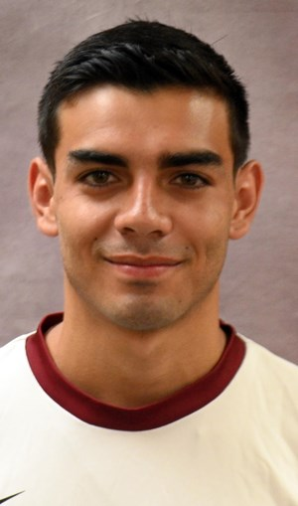
Arturo Astorga
Cell: (915) 207-0313
Email: aastorga16@apu.edu

Bio DOB: March 29, 1998
Height: 5’9
Weight: 155 lbs
Preferred Foot: Switchfoot
Position: Midfield/Forward

Experience:
College
2016-2019: Azusa Pacific University (NCAA DII)
Stats:
5,969 minutes
73 appearances
27 Goals
29 Assist
2016 (freshman): Appeared in all 17 games for the Cougars, starting 15
2017 (sophomore): Earned All-PacWest third-team honors after starting 16 of the 17 games
2018 (junior): United Soccer Coaches All-American second team… D2CCA West Region first team… PacWest first team… appeared in all 20 games, starting 19…
clinched conference title and earned PacWest Player of the Week
2019(senior): PacWest first team…All Region first team…PacWest Player of the Week

References:
Azusa Pacific University Head Coach: David Blomquist, dblomquist@apu.edu (760) 473-2962
Azusa Pacific University Assistant Coach: Andriy Budnyy, abudnyy@apu.edu (704) 795-8626
Rush Select Head Coach: Mike Griego, soccerskills08@gmail.com, (915) 241-2738

